Ideation Phase
Define the Problem Statements

Date | 19 febrauary 2026
Team ID | LTVIP2026TMIDS46924
Project Name | Shop smart
Maximum Marks | 2 Marks

Customer Problem Statement Template:
In today's fast-paced world, customers struggle with the inconvenience of traditional grocery shopping, such as long queues, limited store hours, inconsistent product availability, and the lack of time to physically visit multiple stores. They seek a solution that allows them to browse a wide variety of high-quality groceries, compare prices, and order essentials from the comfort of their homes at any time.
Customers want an easy-to-use platform that ensures timely delivery, fresh produce, transparent pricing, and a seamless checkout experience. Many are also looking for personalized recommendations, real-time stock updates, and flexible delivery options that fit their lifestyle.

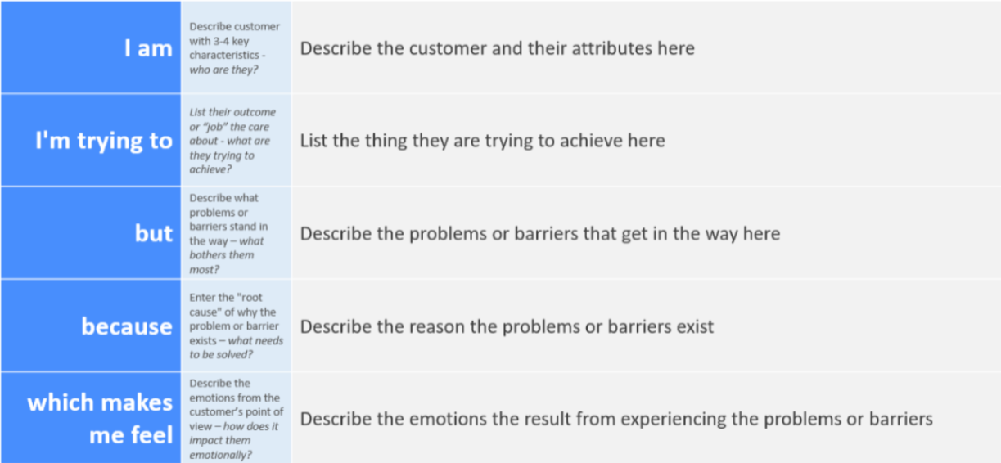
Reference: https://miro.com/templates/customer-problem-statement/

Problem Statement (PS) | I am (User) | I’m trying to | But | Because | Which makes me feel
PS-1 | A busy professional | Quickly buy my weekly groceries online | I often struggle to find specific items or discover new products efficiently, and the checkout process can be clunky. | Many existing grocery apps have cluttered interfaces, poor search functionality, or multi-step checkouts that waste time. | Frustrated and like my time is being wasted, leading me to sometimes just go to a physical store despite the inconvenience.
PS-2 | A health-conscious individual | Easily track my dietary preferences and discover products that align with them | It's difficult to filter products accurately by specific dietary needs, and there's no easy way to get recommendations based on my health goals. | Current apps often lack robust filtering options for dietary restrictions or personalized recommendation engines based on user health profiles. | Annoyed and overwhelmed by having to manually check every product, making it harder to stick to my diet and impacting my health goals

